Lab09
Muhammad Zain Ali
22i-0562

Example :

#include <iostream>
using namespace std;
int main (){
int rows;
cout<<"Enter rows: ";
cin>>rows;

for (int i=1; i<=rows;++i){

for (int j=1;j<=5; ++j){
cout<<"*";
}
cout<<endl;
}

return 0;
}

Output :
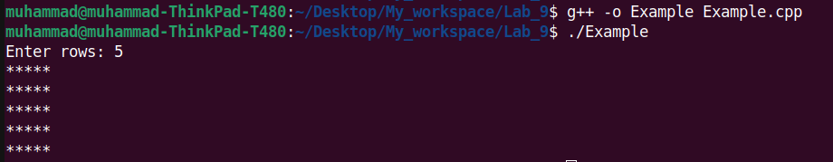
Question 1:

#include <iostream>
using namespace std;
int main (){
int x = 1;
while(x<=5)
{
x++;
cout<<"Yawning is from the devil so whenever one of you yawns, then let him try to suppress it as much as possible.\n\n"<<"(Bukhari and Muslim)\n";
}

return 0;
}

Output :
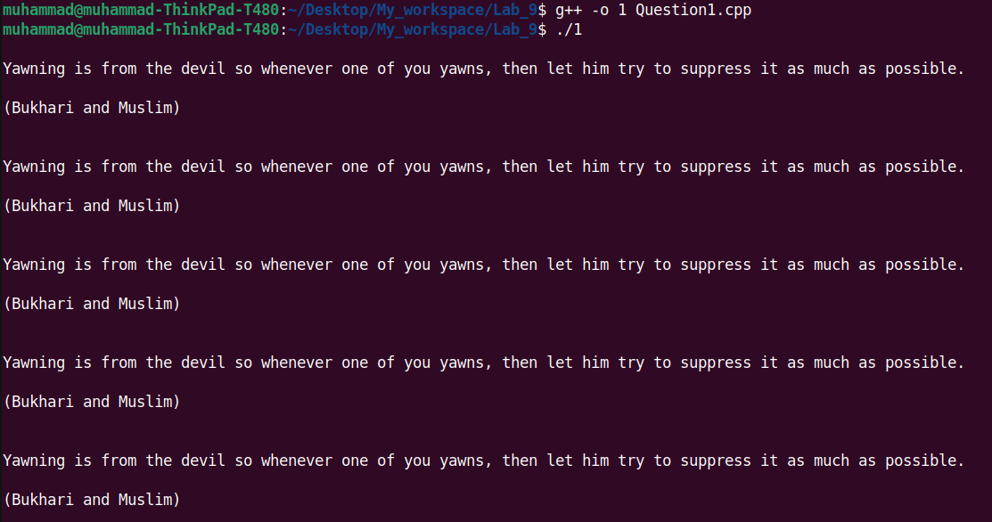
Question 2a :

#include <iostream>
using namespace std;
int main (){
int rows;
cout<<"Enter number of rows: ";
cin>>rows;
int n =1;
for(int i = 1; i<=rows; i++){

for(int j = 1; j<=i; j++){

cout<<n;
n++;
}
cout<<endl;

}

return 0;
}

Output :

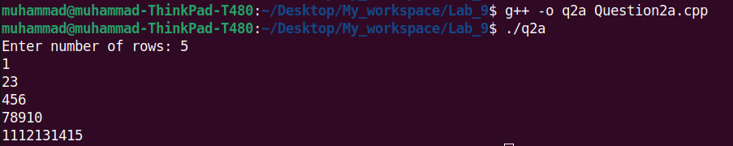
Question 2b :

#include <iostream>
using namespace std;
int main (){
int rows;
cout<<"Enter rows: ";
cin>>rows;

int i =1;
do{

int j=1;
do{
cout<<"*";
j++;
}while(j<=i);

cout<<endl;

i++;
}while(i<=rows);

return 0;
}

Output :

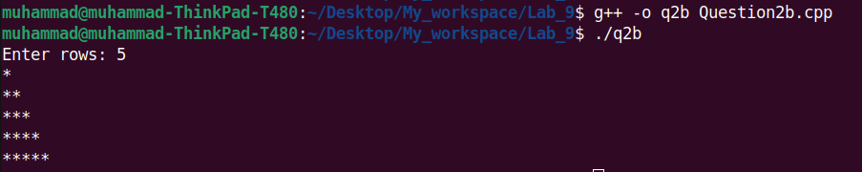

Question 2c :

#include <iostream>
using namespace std;
int main (){

int rows =1 ;
cout<<"Enter number of rows: ";
cin>>rows;

int i = 1;
while(i<=rows)
{

int x =rows-i , f =1;

while(f<=x)
{
cout<<" ";
f++;
}
int j = ((i*2)-1) , l=1;
while(l<=j)
{
cout<<"*";
l++;
}
cout<<endl;

i++;
}

return 0;
}

Output :

